NEWS RELEASE

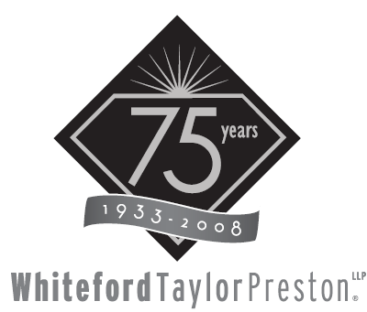

FOR IMMEDIATE RELEASE
CONTACT:
Kristin L. B. Lemmert
410.347.9423
klemmert@wtplaw.com
Seven Saint Paul Street
Baltimore, Maryland 21202

39 Whiteford, Taylor & Preston Attorneys Named Among Maryland’s
Super Lawyers and Rising Stars: Nussbaum and Ryan Named Among Top 50

January 21, 2009 – Baltimore – Whiteford, Taylor & Preston is pleased to announce that 39 of its attorneys are listed among the 2009 Maryland Super Lawyers: Thomas C. Barbuti, Edward M. Buxbaum, Mary Claire Chesshire, Jonathan E. Claiborne, Robert B. Curran, William M. Davidow, Jr., Deborah H. Diehl, Edwin G. Fee, Jr., Martin T. Fletcher, James P. Gillece, Jr., John B. Gontrum, Peter D Guattery, Harry S. Johnson, Frank S. Jones, Jr., Paul W. Madden, Natalie C. Magdeburger, Jonathan Z. May, Roseanne M. Matricciani, Kevin C. McCormick, Albert J. Mezzanotte, Jr., Paul M. Nussbaum, Kenneth Oestreicher, Herman B. Rosenthal, William F. Ryan, Jr., Brent C. Strickland, Steven E. Tiller, Warren N. Weaver, Robert M. Wright, and Thurman W. Zollicoffer, Jr. Nussbaum and Ryan were also named among Maryland’s Top 50 Lawyers.

Additionally, James R. Benjamin, Jr., Kevin G. Hroblak, Dino C. La Fiandra, Jennifer Ryan Lazenby, Edward M. Lee, III, Dana O. Lynch, Dennis M. Robinson, Jr., R. Christopher Rueppell, Elliott D. Petty, and Melissa Menkel Shorey are named as Maryland Rising Stars 2009.

The attorneys at Whiteford, Taylor & Preston are dedicated to helping our clients achieve their business goals through strategic legal counsel. We serve our clients across the nation and around the globe, wherever your business takes us, from our base of six offices in the mid-Atlantic region. For more information, please visit our website at www.wtplaw.com.

# # #

